Copy of Facultus Loan Offer Page 1 of 4
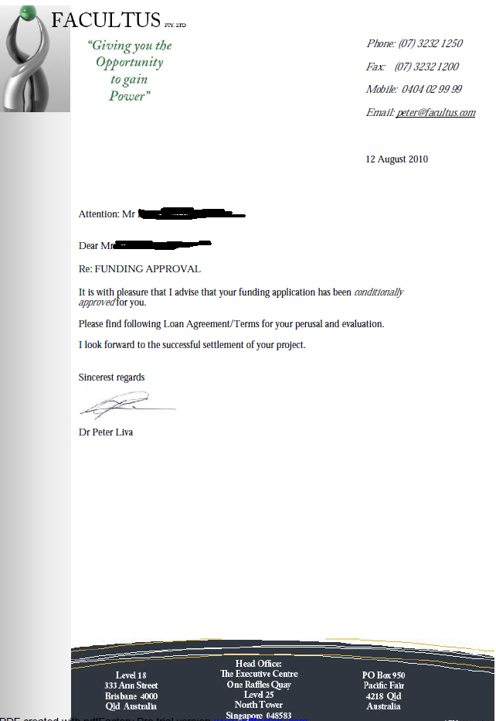

Continued on Page 2
Page 2 of 4
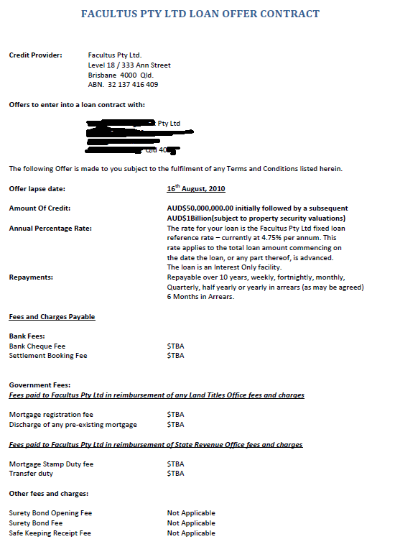

Continued on page 3
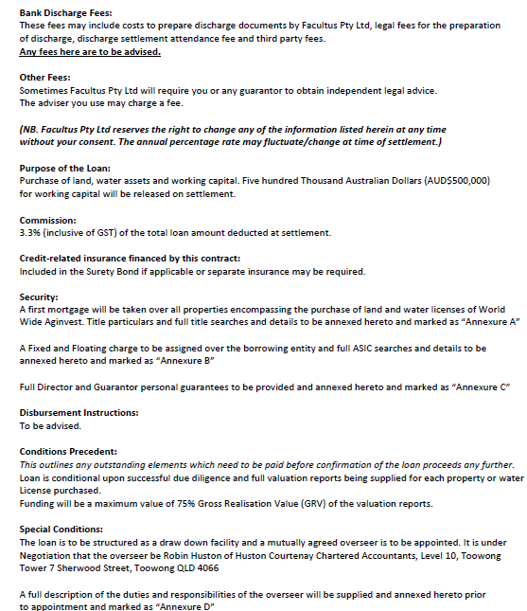

Continued on page 4

Last page

